**DMX Guide**

**Overview:**

**DMX ( Data Management Express)** application is being used to create the Master data into SAP through Robotic Automation BOT process

1. **Introduction**
   1. **Purpose:**

This doucment is a guide for new users to DMX application.

* 1. **Acronyms**

|  |  |
| --- | --- |
| **Acronym** | **Details** |
| DMX | Data Management Express |

* 1. **Audience**

**DMX** application users

1. **DMX:**
   1. **DMX APPLICATION URL : <https://dmx.tapestry.com>**
   2. If user is already logged-in or the user session is alive then user can access the application through this URL: **<https://dmx.tapestry.com>**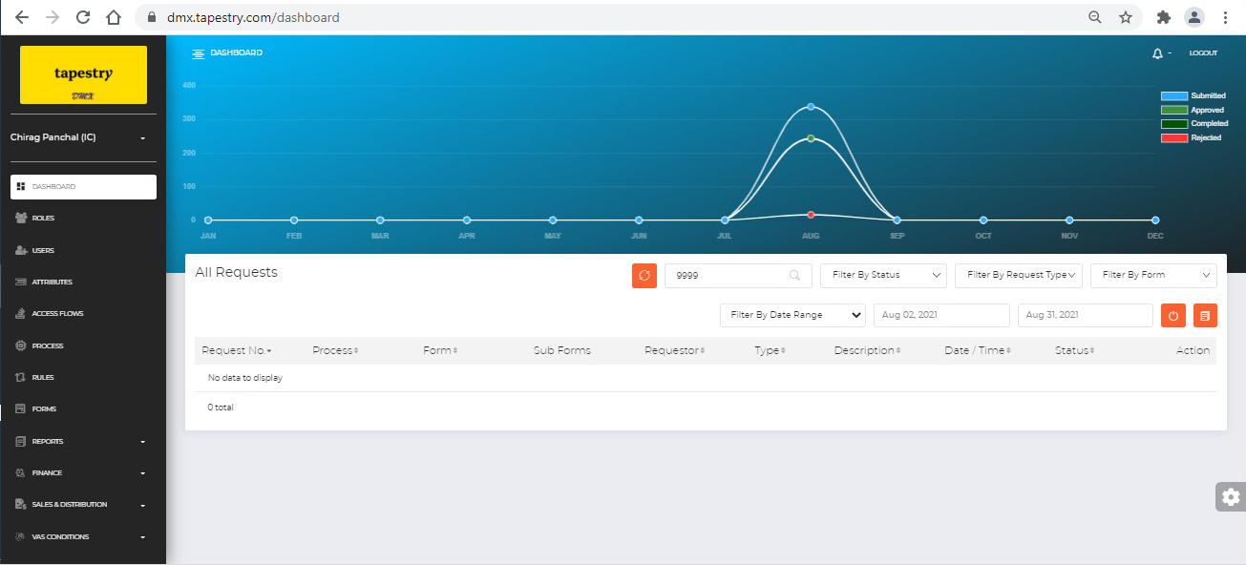
   3. If User session is expired or User is accessing the applicaton for the first time then user needs first access the SSO URL and it will automatically log the user in and redirect it DMX dashboard

**SSO URL: <https://dmx.tapestry.com/ssologin>**

* 1. If User’s session has expired or User is accessing the application for the first time and if User is trying to access the application through below URL then User will see the blank/white page with no content

**URL: <https://dmx.tapestry.com>**

